|  |  |
| --- | --- |
| Project | Opencart |
| Tested by | Siva |
| Test Execution Date | dd-Mmm-yy |
| Test Cycle | 1 |
| Test Environment | localhost |
| Version, Release, Build Number | 1, 1, 1 |
| Test Scenario Number | TS0001 |
| Test Scenario | Register Functionality |
| Test Case ID | TC_RF_0001 |
| Test Case Description | Validate Registering an account by providing all the fields (Mandatory and Non-mandatory fields) |
| Test Steps | 1. Click on 'My Account' drop-down menu  2. Click on 'Register' option  3. Enter new account details into all fields(First Name, Last Name, Email, Telephone, Password, Password Confirm, News letter, Privacy Policy)  4. Click on 'Continue' button(ER-1)  5. Click on 'Continue button displayed in Account Success page(ER-2) |
| Test Data | Not Applicable |
| Expected Result | 1. User should be logged in and navigated to Account Success Page and proper details should be displayed on the page.  2. User should be navigated to Account page. |
| Actual Result | As Expected |
| Test Result | Pass |
| Bug/Defect ID | Not Applicable |
| Steps to Reproduce | Not Applicable |

1. Click on 'My Account' drop-down menu

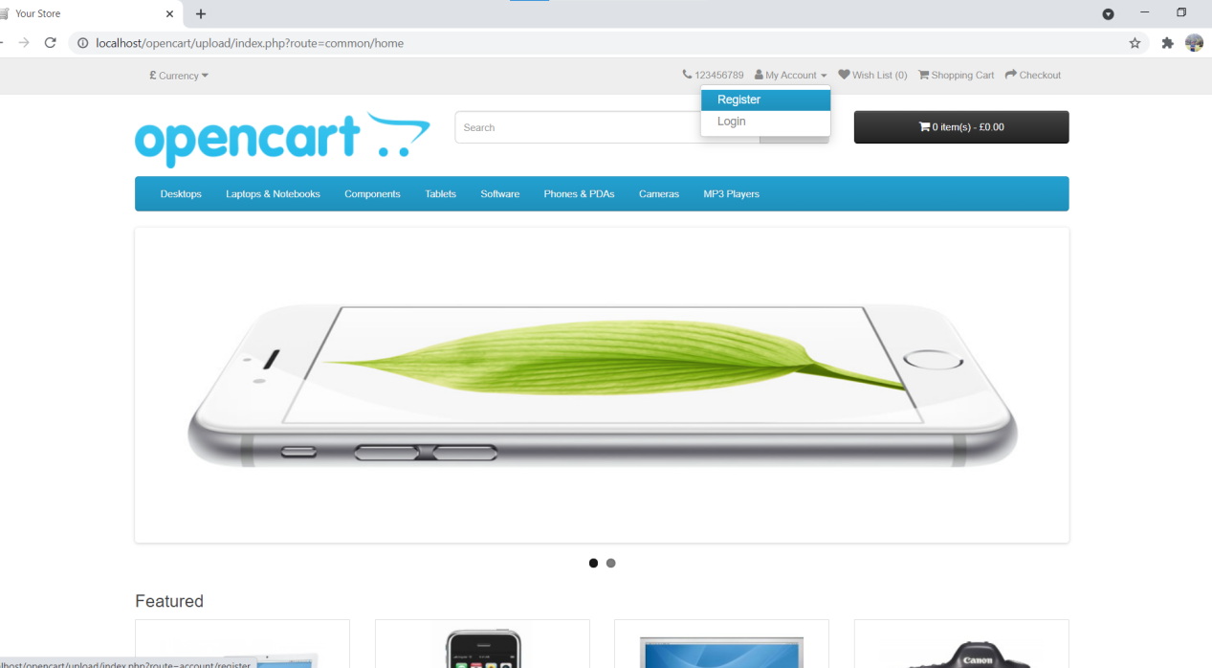

2. Click on 'Register' option

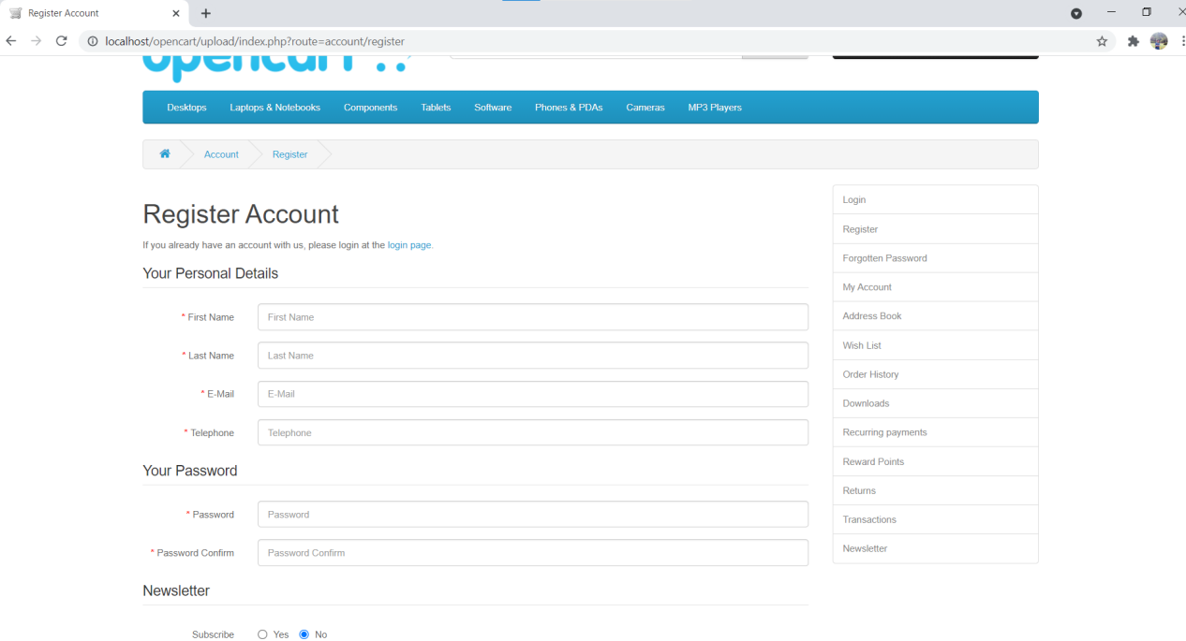

1. Enter new account details into all fields(First Name, Last Name, Email, Telephone, Password, Password Confirm, News letter, Privacy Policy)

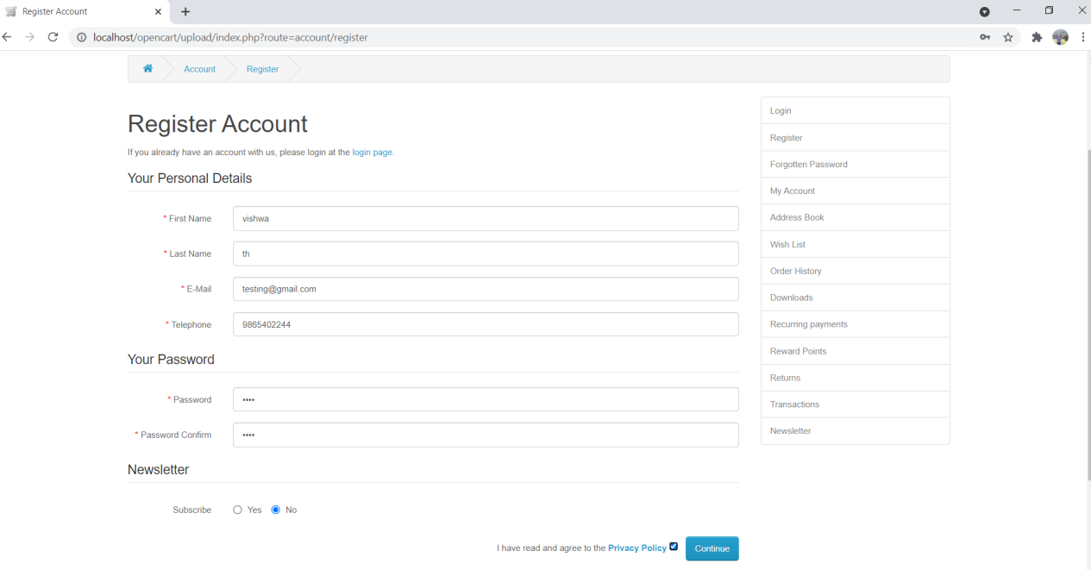

1. Click on 'Continue' button(ER-1)

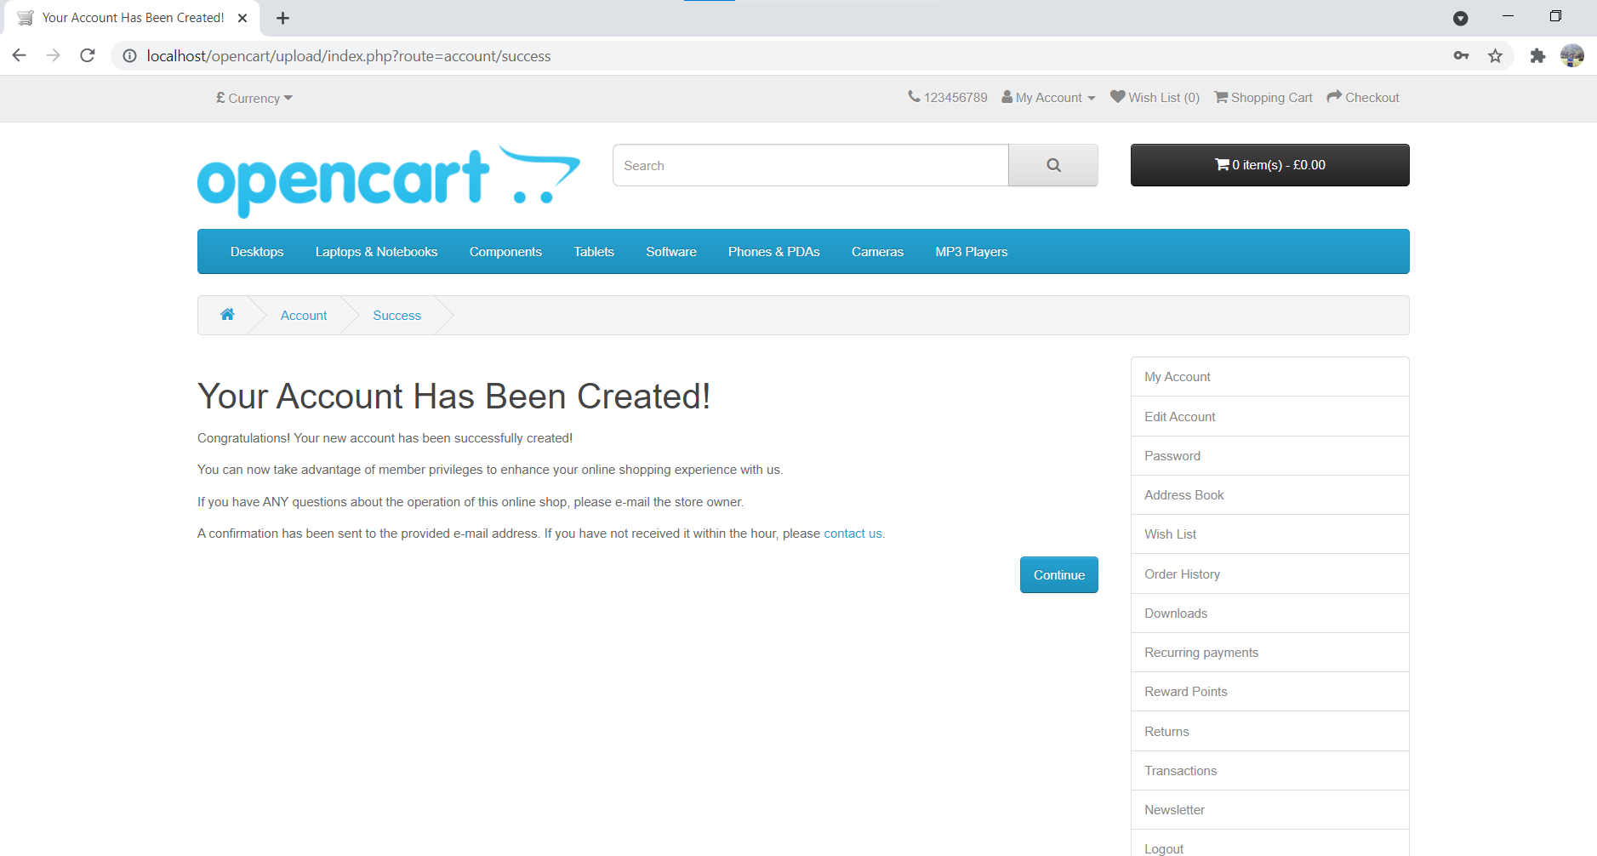

1. Click on 'Continue button displayed in Account Success page(ER-2)

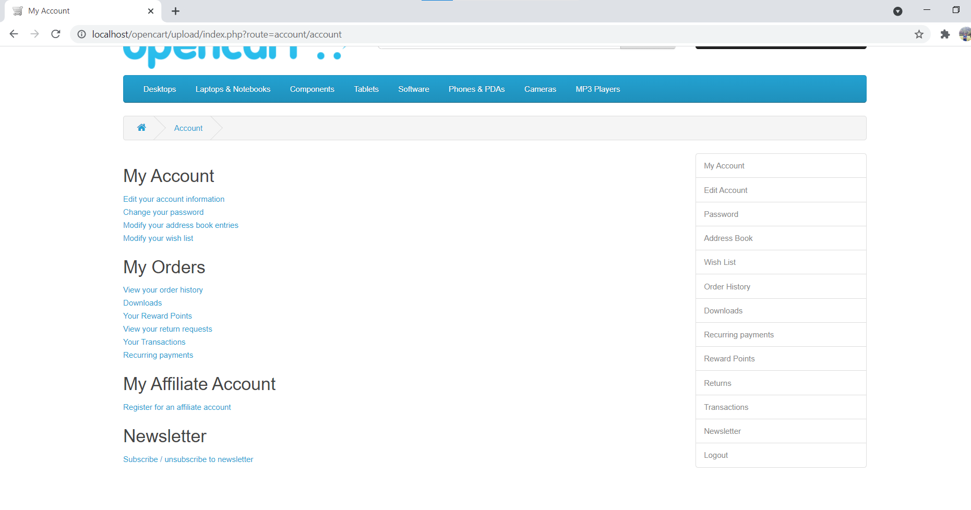

After registration, Confirm email received in mailbox (to be saved in test result folder as a evidence)